|  |
| --- |
| **International School**  CAPSTONE PROJECT 2  **CMU-SE-451**  Proposal Document  v 1.0  Green Big5 Information System  Submitted by  Chung, Hoang Bao  Loc, Tien Nguyen  Vinh, Quang Do  Kha, Van Ngo  **Approved by**  **Capstone Project 2 - Mentor:**  Name Signature Date      Nguyen Thanh Binh  18.02.2022 |

**PROJECT INFORMATION**

|  |  |  |  |  |
| --- | --- | --- | --- | --- |
| **Project acronym** | GB5 | | | |
| **Project Title** | GreenBig5 | | | |
| **Start Date** | 01 March 2022 | **End Date** | | 16 May 2022 |
| **Lead Institution** | International School, Duy Tan University | | | |
| **Project Mentor** | Doctor. Habil. Binh, Thanh Nguyen | | | |
| **Scrum master / Project Leader & contact details** | Loc, Tien Nguyen  nguyentienloc18122000@gmail.com  StudentID: 24211202217 | | | |
| **Partner Organisation** | N/A | | | |
| **Project Web URL** | N/A | | | |
| **Team members** | Student ID | Name | Email | Tel |
| 1 | 24211207051 | Chung, Hoang Bao | [baochunga1@gmail.com](mailto:nguyentienloc18122000@gmail.com) | 0889192932 |
| 2 | 24211210573 | Kha, Van Ngo | ngokha437@gmail.com | 0935950384 |
| 3 | 24211208568 | Vinh, Quang Do | doquangvinh0708co@gmail.com | 0937519169 |

REVISION HISTORY

|  |  |  |  |  |
| --- | --- | --- | --- | --- |
| **Version** | **Date** | **Comments** | **Author** | **Approval** |
| 1.0 | 15- Feb - 2022 | Initiate proposal | Chung, Hoang Bao | X |
|  |  |  |  |  |
|  |  |  |  |  |
|  |  |  |  |  |
|  |  |  |  |  |

TABLE OF CONTENT

**1. Introduction**4

1.1 Propose of this document 4

1.2 Background 4

1.3 Project goal 5

**2. Problem Definition**5

2.1 Non-functional requirement 5

2.2 Functional requirement 5

**3. Current Status of Art**7

**4. Engineering Approach (including solution alternatives)**8

4.1 System Architecture 8

4.2 System Detail 8

4.3 Technical to develop 9

**5. Tasks and Deliverables**10

5.1 Tasks 10

5.2 Deliverables 10

**6. Project Management**11

6.1 Human resources 11

6.2 Cost/Budget for Project 12

6.3 Tentative Schedule 12

6.4 About Scrum 13

6.5 The reason we use Scrum 13

**7. Project Constraints**13

**8. Conclusion**14

**9. References**15

### 1. Introduction

#### 1.1 Propose of this document

- Define the business need and problem in detail.

- Provide solutions for business needs.

- Provide an overview of the resources, schedule, solution, and budget for the project.

The proposal merely introduces the project to the student development teams and provides the up-front information necessary for the team to develop a specification.

#### 1.2 Background

**1.2.a Environmental state**

Nowadays, the environmental problem is the most concerning problem not only in Viet Nam but the World as well [11]. This problem is the main cause of human development as well as civilization. For example, air pollution from the factory’s emissions is one of the main reasons for many dermatological diseases, or the biggest destruction from air pollution is the ozone layer that was punctured the first time on September 9th, 2000, and it has been punctured a lot since then [9]. There is increasing awareness of the subject of environmentalism around the world. According to research in the United States, public awareness of climate change has increased in the last decade [14]. Almost 97% of people are aware of global warming and environmental problems [15]. According to Gifford (2008) [13], climate change is affecting many people and places with global warming, pollution, and severe weather patterns; this trend will continue unless changes are made to protect the environment [10].

**1.2.b Big5 model**

Big5 model, known as O.C.E.A.N model [8], is a psychological model researched and developed by many scientists around the world. Five factors of the Big5 model are: Openness to knowledge/ experience (O), conscientiousness (C), extraversion (E), agreeableness, and neuroticism (N) as illustrated in figure 1-1 [ 6, 8,10]. This model is believed that each personality has five factors(Big5 traits) and it determines the expression level of each of these factors [8] . The big5 models of personality traits have shown to be reliable in predicting many areas of a person’s life [10]. For example, positive and negative affect, life and marital satisfaction, career achievement, and life span are correlated with big five traits [8].

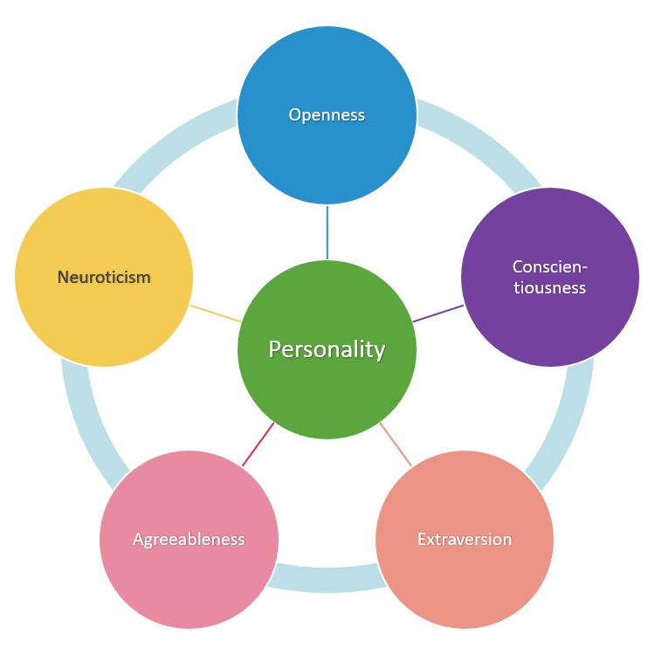

**Figure 1-1.4:** Big five personality model

**1.2.c Big5 trait and environment impact**

According to [10], Big5 personality traits and environment have an engagement. Following a study, they found that there is a positive correlation between environmental concern and the personality traits of agreeableness and openness. They also found the traits of neuroticism and conscientiousness to be correlated, but not as strongly. In this study, they determined if concern and attitudes were also related to performing pro-environmental behaviours. The purpose of this study was to explore if there was a positive relationship between one or more personality traits of the big five and proenvironmental attitudes and behaviours [6].

From [6], we started our GreenBig5 (GB5) project to collect user personality traits, from that to find their effect on the environment and have solutions for each type of Big5 personality trait. This could help the government and the enterprise know about their customers and have a strategy for them to reduce their harmful effect on the environment [6,10].

#### 1.3 Project goal

The aim of this project is to build a GreenBig 5 information system (GB5), i.e., GB5 App, database and GB5 Dashboard:

* GB5 Dashboard: Support for create question packages which used to direct the user follow the environment theme. With each question, users can be distributed by Indicator (2). Finally, by using a prediction method to predict the user's personality traits (3) and predicts linkings between big5 traits and environmental impacts.

Implemented through 3 steps:

1. Expert models: expert users use the dashboard to specify the linkings between big traits -facets and environmental keywords structured in tree formats.
2. Questions are defined and generated based on the expert model (1).
3. Predict and verify expert model by using answer results of (2), Based on that. we can verify if the expert model is apllied for which group(s) of users.

* GB5 App (Update): GB5 Application receives user activity data by listening to the event, the state, of the system emitted through Intent so that the system can find out the user’s location based.

As a result, government authorities, enterprises, as well as users would have an overview of the environment and have a better solution to change user behaviour and to reduce and prevent it from the bad effect.

### 2. Problem Definition

#### 2.1 Non-functional requirement

Below is the non-functional requirement that are being offered for this system:

* **Security**: Users can use the system without the fear of revealing personal information.
* **Usability**: with a friendly and flexible user-interface, users can have a great experience when using the system.
* **Portability and compatibility:** The system is operated on the Fullter framework and can run on any Operating system such as Android or IOS.

#### 2.2 Functional requirement

Below is the functional requirement that are being offered for this system, which are the main purpose of this project:

* GB5 App
  + Login/Sign in: Users can login to the BG5 Application to use it if they already have an account, or they can register if they don’t.
  + View the question: Users can see the question in the BG5 Application.
  + Answer the question: Users can answer the question in the application.
  + Collect user datalog: Based on user activity log, system can predict user’s personality data in a specific view.
* GB5 data management system
* Store user information.
* Store Big5 indicator, so that the Model can receive to predict Big5 traits.
* Store user’s Answer.
* Interact with the GB5 App to show the question.
* Send the big5 questions based on the big5 scenario [**].
* Show data into a dashboard to manage the data.
* GB5 Dashboard
* Visualise User trait data, sent question
* Visualise User trait point
* Send question to user setted by Big5 Scenario [**].
* Store question, Big5 Indicator [*].
* Automatically generate questions through an AI model.
* Create flow for Big5-Env keyword.
* Predict the generated flow true of false through an AI model.
* AI Model
* Generate questions by Big5-Env keyword.
* Predict the generated flow true of false.

#### 2.3 Some definition in this project

In this project, you would see some strange words or theoretical definitions, this could explain briefly about them:

**Big5 indicator [*]**

The Big5 indicators are the characteristics, a sign of presence or absence of one or many Big5 traits.

As we know, Big5 divides into 5 different traits (O.C.E.A.N) [6,7,8,10]. Based on that, the Big5 indicator will be retrieved and calculated from these traits. Some examples of the big5 indicator are:

* Logic game: Calculated when the users answer the question about their hobbit with the logical game.
* Do something during an argument or business: Calculated when users answer the question about their behaviour when they have a fight or an argument.
* Detail-oriented: Calculated when users answer the question about the behaviour of their daily life/work.

By using the Big5 indicator, we can calculate the Big5 trait of the user based on their answer on the GB5 Application. This support will set-up a dataset for machine learning.

**Big5 Scenario [**]**

The Big5 scenario provided a questions/answers route for the GB5 Application based on many types of users such as: the new user, the user who has been using the Application, ... Not only that, but this set-up rule also sends the question to a specific user’s group. This would help the system have a specific for classifile user personality trait.

**Pro-Environmental behaviours:** Behaviours that are aimed at reducing climate

change or consequences of climate change (Gifford, 2008).[6]

**Pro-Environmental concern:** Values, attitudes, and beliefs that a person has that

leads them to be ecologically conscientious (Jimenez-Sanchez, & Lafuente, 2008). There

is also a belief that all people have a relationship with the environment (Jimenez-Sanchez

& Lafuente, 2008). Often these attitudes will lead to behaviours or actions to protect the

environment. The terms concern and attitude may be used interchangeably.[6]

### 3. Current Status of Art

Some research has been made to find the connection between the Big-five personality trait and environmental behaviour:

[6] is research created by Tara Rae Wuertz from Walden University, Minneapolis, Minnesota. USA in 2015. By surveying the student, they have found the correlation with a person's pro-environmental behaviour and the big5 personality traits. [<https://www.proquest.com/openview/f425c164f6b1921a0de75c9ef707de98/1?pq-origsite=gscholar&cbl=18750>]

[7] is a project operated by Doctor. Habil. Binh, Thanh Nguyen and partners to find the user’s personality trait by using their mobile log data. [<https://link.springer.com/chapter/10.1007/978-981-32-9186-7_25>].

[8] is a website to find user’s big-five traits by using a specific survey call - big5 survey. This also has a lot of research about the big-five, and the big-five’s usability [<https://bigfive.vn/>].

It can be seen that Big-five personality traits have been used in many different ways such as finding jobs, directing users to use suitable services…. But now, we are facing the consequences of what we do to the environment. By using Big5 personality traits this would help the government and the enterprise and any organisation who has an interest in the environment problem.

Although Big5 models have been applied in many software products to help people in making decisions, there wasn't any help in making decisions to protect the environment [6,10]. This is the reason we built this system called Big Green 5 (GB5), which includes a BigGreen Application to collect user data, the BigGreen Dashboard to generate the question and calculation to predict the personality of the user based on the answer and the indicator. With the BigGreen system - the first system to help governments and organisations in protecting the environment in the market, we can find out the user's personality, after that we find the impact of the user to the environment to have a better solution to limit bad effects to the environment.

### 4. Engineering Approach (including solution alternatives)

#### 4.1 System Architecture

**Figure 1-4.1:** *System Architecture Overview of GreenBig5 System*

In this system, GB5 App is used to collect user data based on answered Big-five questions, which have been stored in the database. Meanwhile, the Application will collect user activity logs based on which the system can collect user activities to get a specific view of the user's personality.

In addition, the GB5 database will store Big5 metrics, encrypted user activity data and questions, as well as store user data and their personality traits. also stores a packet of questions about each characteristic for users, who have been using the application. Based on the big5[**] scenario, the GB5 database can send questions to the GB5 App for users to view and answer. This will help the system send questions to the user without intruding on the user's privacy.

Finally, the GB5 Dashboard allows experts to create model trees (Facet + Env keywords), which automatically generate question packs and display answer data visually. So the system will classify the user into a tempered group (O, C, E, A, N) based on the Big5 Index[*]. The system will automatically resend questions to that group according to rules from Big5 Scenario [**] and based on user activity logs collected in GB5 App using AI model. The system will re-filter the user to have a specific view of the user's personality and find the connection between the user and the environment.

#### 4.2 System Detail

**4.2.a GB5 App**

* Interact with users using the system.
* Allow user to use these function:
* Login/Sign up.
* View the question.
* Answer the question.
* Logout
* Edit user information
* Interact with GB5 Database to store data.
* Collect user information: Phone number.
* Show Big-five questions for the user to answer.
* Collecting user’s location data.

**4.2.b GB5 Database**

* Storage user data, user personality trait, Big-five question and indicator.
* Interact with GB5 Application to send questions based on the Big-five scenario [**].
* Receive a question in the dashboard and send it to the user.

**4.2.c GB5 Dashboard**

* Visualise User trait data.
* Visualise User trait points.
* Generate questions through an AI model.
* Display user information.
* Send question to all users.
* Create flow for Big5-Env keyword.
* Predict the generated flow true of false through an AI model.

**4.2.d AI Model**

* Generate questions by Big5-Env keyword.
* Predict the generated flow true of false.

#### 4.3 Technical to develop

Main programming language: JavaScript, Dart, Python

**4.3.a GB5 Application:**

* Programming Language: Dart, Flutter.
* Tool: Android studio.

**4.3.b GB5 Database:**

* Programming Language: NodeJs
* Database: MongoDB
* Tool: Visual studio code.

**4.3.c GB5 Dashboard:**

* Programming Language: NodeJs, Python, ReactJs
* Tool: Visual studio code.

**4.3.d AI Model:**

* Programming Language: Python
* Tool: Visual studio code.

**4.3.e Communication, Management, Design tool**

* Communication: Skype, Mail, Slack.
* Management: Github, Trello.
* Design: Figma, Draw.io

### 5. Tasks and Deliverables

#### 5.1 Tasks

|  |  |
| --- | --- |
| Task  Number | Task title |
| 1 | Prepapreration. |
| 2 | Maintenance of the previous version of the system. |
| 3 | Research AI. |
| 4 | Build an AI model to generate Big5 questions. |
| 5 | Build an AI model to classify users' personality and send questions to classified users. |
| 6 | Build collects user activity data function. |
| 7 | Build UI for Dashboard. |
| 8 | Update physical database. |
| 9 | Update database. |
| 10 | Develop collect user activity data function. |
| 11 | Test generates question AI model. |
| 12 | Tests classify user’s personality AI model. |
| 13 | Integration new function and AI model |
| 14 | Release |

**Table 5.1:** Tasks

#### 5.2 Deliverables

|  |  |  |
| --- | --- | --- |
| **No** | **Active(s)** | **Deliverables** |
| 1 | Project proposal | Project proposal document v1.0 |
| 2 | Project Plan | Project plan document v1.0 |
| 3 | Product backlog | Product backlog document v1.0 |
| 4 | Architecture Document | Architecture Document v1.0 |
| 5 | Database Design | Database Design Document v1.0 |
| 6 | Interface Design | Interface Design Document v1.0 |
| 7 | Test plan | Test plan document v1.0 |
| 8 | Test case | Test case document v1.0 |
| 9 | Acceptance Criteria | Acceptance criteria v1.0 |
| 10 | Sprint backlog & Burndown Chart | Sprint backlog & Burndown Chart v1.0 |
| 11 | Team Reflection | Team reflection v1.0 |
| 12 | Technology stack | Technology stack document v1.0 |
| 13 | Description of requirement | Description of requirement v1.0 |

**Table 5.2:** Deliverables

### 6. Project Management

#### 6.1 Human resources

|  |  |  |  |
| --- | --- | --- | --- |
| **Full name** | **Phone** | **Email** | **Position** |
| Binh, Thanh Nguyen | 0905 881 881 | binh.iiasa@gmail.com | Mentor, Stakeholder |
| Vinh, Quang Do | 0937519169 | doquangvinh0708co@gmail.com | Full-stack Developer |
| Chung, Bao Hoang | 0889 192 932 | baochunga1@gmail.com | AI Developer |
| Loc, Tien Nguyen | 0932478789 | nguyentienloc18122000@gmail.com | Back-end Database,Application developer |
| Kha, Van Ngo | 0935950384 | ngokha437@gmail.com | Back-end Developer,  Application developer |

**Table 6.1:** *Human Resource*

#### 6.2 Cost/Budget for Project

|  |  |  |
| --- | --- | --- |
| **Sprint** | **Duration(hour)** | **Cost ($)** |
| 1 | $376 | $752 |
| 2 | $356 | $712 |
| 3 | $387 | $774 |
| 4 | $498 | $1996 |
| **Total** | **1617** | **$4234** |

**Table 6.2:** *Cost/Budget for Project*

#### 6.3 Tentative Schedule

|  |  |  |  |  |
| --- | --- | --- | --- | --- |
| **No** | **Task name** | **Duration** | **Start** | **Finish** |
| **1** | **Pre-study** | **8 days** | **15-Feb-2022** | **04-March-2022** |
| 1.1 | Gathering requirement | 2 days | 15-Feb-2022 | 17-March-2022 |
| 1.2 | Create proposal document | 1 days | 17-Feb-2022 | 18-Feb-2022 |
| 1.3 | Project Kick-off Meeting | 1 days | 18-Feb-2022 | 19-Feb-2022 |
| 1.4 | Submit proposal | 3 days | 19-Feb-2022 | 22-Feb-2022 |
| 1.5 | Present proposal | 1 days | 22-Feb-2022 | 23-Feb-2022 |
| **2** | **Development** | **84 days** | **23-Feb-2022** | **12-May-2022** |
| 2.1 | Sprint 1 | 28 days | 23-March-2022 | 16-March-2022 |
| 2.2 | Sprint 2 | 28 days | 16-March-2022 | 06-Apr-2022 |
| 2.3 | Sprint 3 | 28 days | 06-Apr-2022 | 27-Apr-2022 |
| 2.4 | Sprint 4 | 21 days | 27-Apr-2022 | 11-May-2022 |
| **3** | **Retrospective** | **1 days** | **12-May-2022** | **13-May-2022** |
| **4** | **Final Release** | **3 days** | **14-May-2022** | **18-May-2022** |

**Table 6.3:** *Master plan*

#### 6.4 About Scrum

Scrum is an agile method, so it follows the principles of Agile Manifesto (<http://hanoiscrum.net/hnscrum/learning/97-manifesto>). In addition, Scrum operates on three core values, also known as Scrip Scripps, including Scrutiny, Inspection and Adaptation.

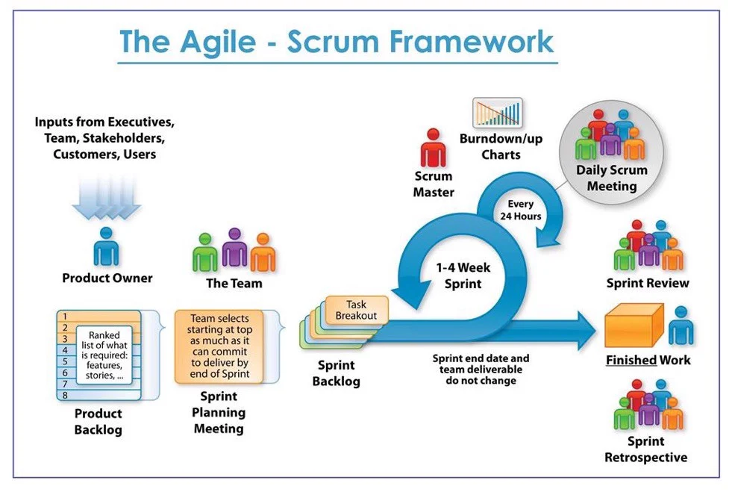

**Figure1-6.3** *The Agile-scrum framework*

Based on the empirical process control theory, Scrum uses iterative and incremental algorithms to optimise efficiency and control risk. Scrum is simple, easy to learn, and has wide applicability. To be able to use Scrum, we need to understand and apply the elements that makeup Scrum include the core values (also known as the "three legs", or the three pillars of Scrum), roles, Events, and Scrum-specific artefacts.

#### 6.5 The reason we use Scrum

* Team has 4 members
* The project will be continuously horizontally scaled up.
* There is only a short amount of time to finish the project.

So, for these reasons, we believe using Scrum as a life cycle is a good choice for this project.

### 7. Project Constraints

|  |  |  |
| --- | --- | --- |
| **Constraint** | **Constraints Description** |  |
| **Economic** | In terms of cost, because it is a system for collecting data for classification purposes, the main problem lies in the cost of research, implementation of a fully automatic system and intelligent user interface. There is also the cost of server rental and server deployment, advertising, ... | Human resource cost: Must be around $600.  Maintenance cost: Should be around $500.  Operation cost: Should be under $1200  Installation costs each intersection around $1000. |
| **Environmental** | This supports organisations to reduce and have solutions to protect the environment. As well raise awareness to users about their behaviour impacting the environment. | Support for reducing bad effect of human to environment |
| **Public health, safety, and welfare** | By raising awareness about the user's personality to the environment, this could increase user health. | This is due to user activity on their device. |
| **Social and Global** | Benefit:  Help organisations and governments to help people in protecting the environment.  Risks:  It can be affected in the user lifestyle while the government or the organisation apply solutions based on what we provide. | Addresses aspects such as benefits, risks, the man-machine interface, the acceptance of products by the intended user or by society at large, global, and socially responsible engineering. |
| **Sustainability** | It is necessary to maintain the continuous operation of the system, so that system can update user data frequently | Development and maintenance work must be ensured to take place  continuously, when issues are reported, it is necessary to focus on maintenance immediately. Server the operation also needs to  be ensured not to be interrupted. |

**Table 7**: *Constraints*

### 8. Conclusion

This project will be finished in 12 weeks and divided into 4 sprints. It promises to be convenient and friendly not only for the government, but organisation also … and those environmental lovers who want to protect it. This will be a handful system for enterprises to help their customers come closer to their product without facing their impact on the environment as well as a handful tool for dealing with many types of customers. For the Government and the Environment Organisation, our system will be a good way to find a better solution to reduce and protect the environment and global warming.

### 9. References

[1] The Scrum guide:[The Scrum Guide is maintained](https://www.scrum.org/resources/scrum-guide)

[2] Software Development Standards for the Guidance and Control Software

[3] [LaRC Software Engineering (SWE) Process Improvement Initiative (SPII)](https://sw-eng.larc.nasa.gov/)

[4] General Software Coding Standards and Guidelines [Office of Water Prediction](https://www.nws.noaa.gov/oh/hrl/developers_docs/General_Software_Standards.pdf)

[5] Scrum and best practises [Sprint and scrum best practises - Azure Boards](https://docs.microsoft.com/en-us/azure/devops/boards/sprints/best-practices-scrum?view=azure-devops)

[6] Personality Traits Associated with Environmental Concern: <https://www.proquest.com/openview/f425c164f6b1921a0de75c9ef707de98/1?pq-origsite=gscholar&cbl=18750>

[7] Tracking Big5 traits based on mobile user log data: [Tracking Big5 Traits Based on Mobile User Log Data](https://link.springer.com/chapter/10.1007/978-981-32-9186-7_25)

[8] Big-five Viet Nam: <https://bigfive.vn/>

` [9] Ozone depletion: [Ozone depletion - Wikipedia](https://en.wikipedia.org/wiki/Ozone_depletion#:~:text=The%20discovery%20of%20the%20Antarctic,larger%20than%20anyone%20had%20anticipated.)

[10] [How personality traits are associated with environmental engagement](https://environment-review.yale.edu/how-personality-traits-are-associated-environmental-engagement-0): <https://environment-review.yale.edu/how-personality-traits-are-associated-environmental-engagement-0>

[11] Vietnam Veterans' Readjustment: Hearings Before the Committee on Veterans:

[Vietnam Veterans' Readjustment: Hearings Before the Committee on Veterans ... - United States. Congress. Senate. Committee on Veterans' Affairs - Google Sách](https://books.google.com.vn/books?id=wmYSl3I6uj8C&pg=PA40&lpg=PA40&dq=Nowadays,+the+environmental+problem+is+the+most+concerning+problem+not+only+in+Viet+Nam+but+the+World+as+well&source=bl&ots=ooSJ4HCC3h&sig=ACfU3U0GDZN2rSeX9YQHiOud7wGne5_Iag&hl=vi&sa=X&ved=2ahUKEwjR5NGG89jyAhUzyIsBHZWDBuUQ6AF6BAgoEAM#v=onepage&q=Nowadays%2C%20the%20environmental%20problem%20is%20the%20most%20concerning%20problem%20not%20only%20in%20Viet%20Nam%20but%20the%20World%20as%20well&f=false)

[12] Big5 Application: [big-five app list - Tìm trên Google](https://www.google.com/search?q=big-five+app+list&sxsrf=AOaemvKA_eOj77p7-ag-C6YUHH1evhu83A%3A1630324679693&ei=x8csYbvwKZaKr7wPjaqqmA8&oq=big-five+app+list&gs_lcp=Cgdnd3Mtd2l6EAMyBwgAEEcQsAMyBwgAEEcQsAMyBwgAEEcQsAMyBwgAEEcQsAMyBwgAEEcQsAMyBwgAEEcQsAMyBwgAEEcQsAMyBwgAEEcQsANKBAhBGABQ_RJY_RJgxBZoAXACeACAAQCIAQCSAQCYAQCgAQHIAQjAAQE&sclient=gws-wiz&ved=0ahUKEwj775rb2NjyAhUWxYsBHQ2VCvMQ4dUDCA8&uact=5)

[13] Psychology’s Essential Role in Alleviating the Impacts of Climate Change: [2008 Psychology's essential role in climate change.pdf (uvic.ca)](http://web.uvic.ca/~esplab/sites/default/files/2008%20Psychology's%20essential%20role%20in%20climate%20change.pdf)

[14] The Impact of Climate Change on the Agricultural Sector: Implications of the Agro‐Industry for Low Carbon, Green Growth Strategy and Roadmap for the East Asian Region: [Microsoft Word - Final_Paper_The Impact of Climate Change on the Agricultural Sector.doc (unescap.org)](https://www.unescap.org/sites/default/d8files/5.%20The-Impact-of-Climate-Change-on-the-Agricultural-Sector.pdf)

[15] Local Warming: Daily Temperature Change Influences Belief in Global Warming: [Local Warming: Daily Temperature Change Influences Belief in Global Warming - Ye Li, Eric J. Johnson, Lisa Zaval, 2011 (sagepub.com)](https://journals.sagepub.com/doi/abs/10.1177/0956797611400913)

10. Attachment: DESCRIPTION OF PRODUCT REQUIREMENTS FORM